Batch: A1
Roll No.: 16010123012
Experiment No.: 03
Grade: AA / AB / BB / BC / CC / CD /DD

Title: Implementing Infrastructure as a Service using Microsoft Azure Cloud Platform

Objective:
To create a Linux Virtual Machine Instance on Microsoft Azure Platform and access the same through one’s local machine.
To perform basic Linux commands on the created Virtual Machine.

Expected Outcome of Experiment:

CO | Outcome
CO4 | Build cloud services and applications

Related Theory:
Platform as a Service (PaaS) is a cloud computing service model that provides a complete development and deployment platform including operating system, runtime environment, web server, and development tools, allowing users to focus only on application development and deployment. In PaaS, the cloud provider manages the infrastructure and platform, while the user manages only the application code and data.
Responsibilities in PaaS Model:
Layer | Managed By
Physical Infrastructure | Cloud Provider
Virtualization | Cloud Provider
Operating System | Cloud Provider
Runtime & Middleware | Cloud Provider
Web Server | Cloud Provider
Application Code | User
Application Configuration | User
Data | User

Characteristics of PaaS:

1. No Infrastructure Management
Users do not need to create or manage virtual machines, storage, or networking resources.

2. Built-in Runtime Environment
PaaS provides pre-configured runtimes such as Java, .NET, Python, and Node.js.

3. Faster Application Development
Developers can build, test, and deploy applications quickly without worrying about underlying infrastructure.

4. Automatic Scaling
Applications can automatically scale based on workload without manual intervention.

5. Integrated Development Tools
PaaS platforms include tools for CI/CD, monitoring, logging, and version control.

Implementation Details:
- Create an account on Microsoft Azure
https://azure.microsoft.com/en-in/free/students/
- Use Microsoft account or github account for creating account
- Use Somaiya id for verification
- Create a Linux virtual machine in the Azure portal using steps given on this official azure page:
https://docs.microsoft.com/en-us/azure/virtual-machines/linux/quick-create-portal
Include following screenshots:
- Creating Account on the Azure platform (step wise with Screenshots)
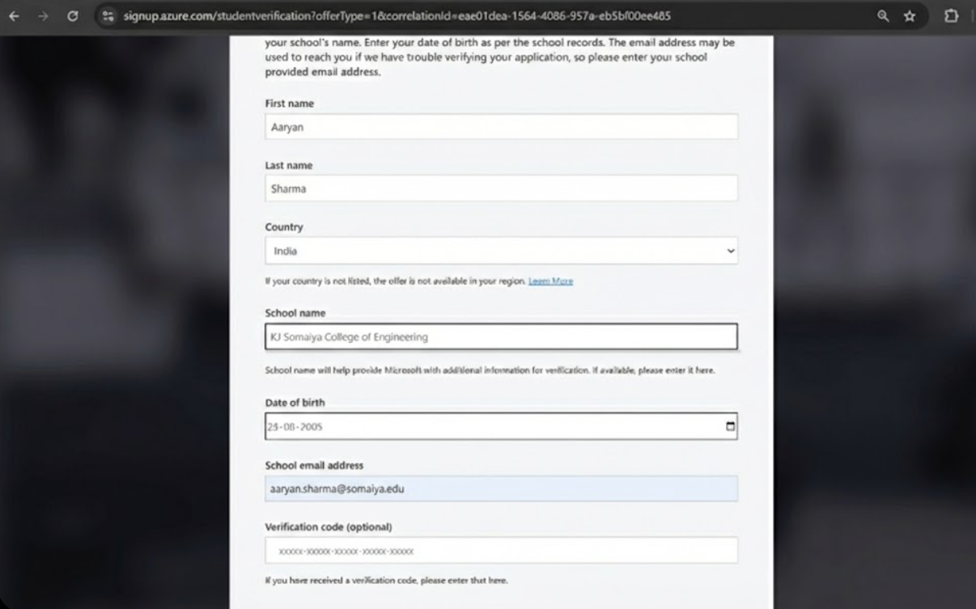
- Creating Virtual Machine Instance on Azure platform (step wise with Screenshots)
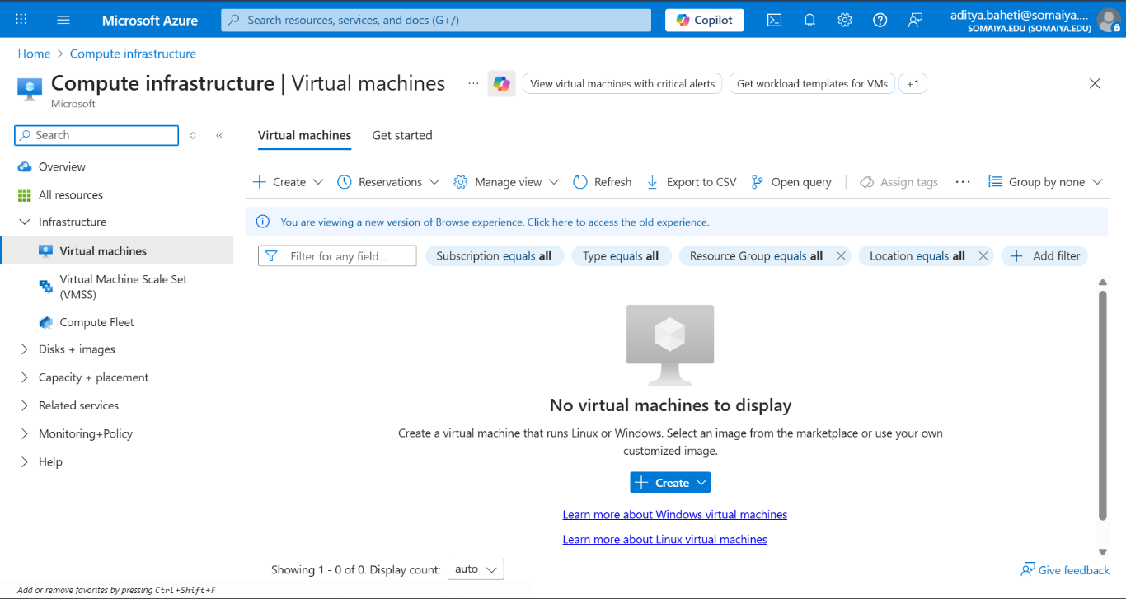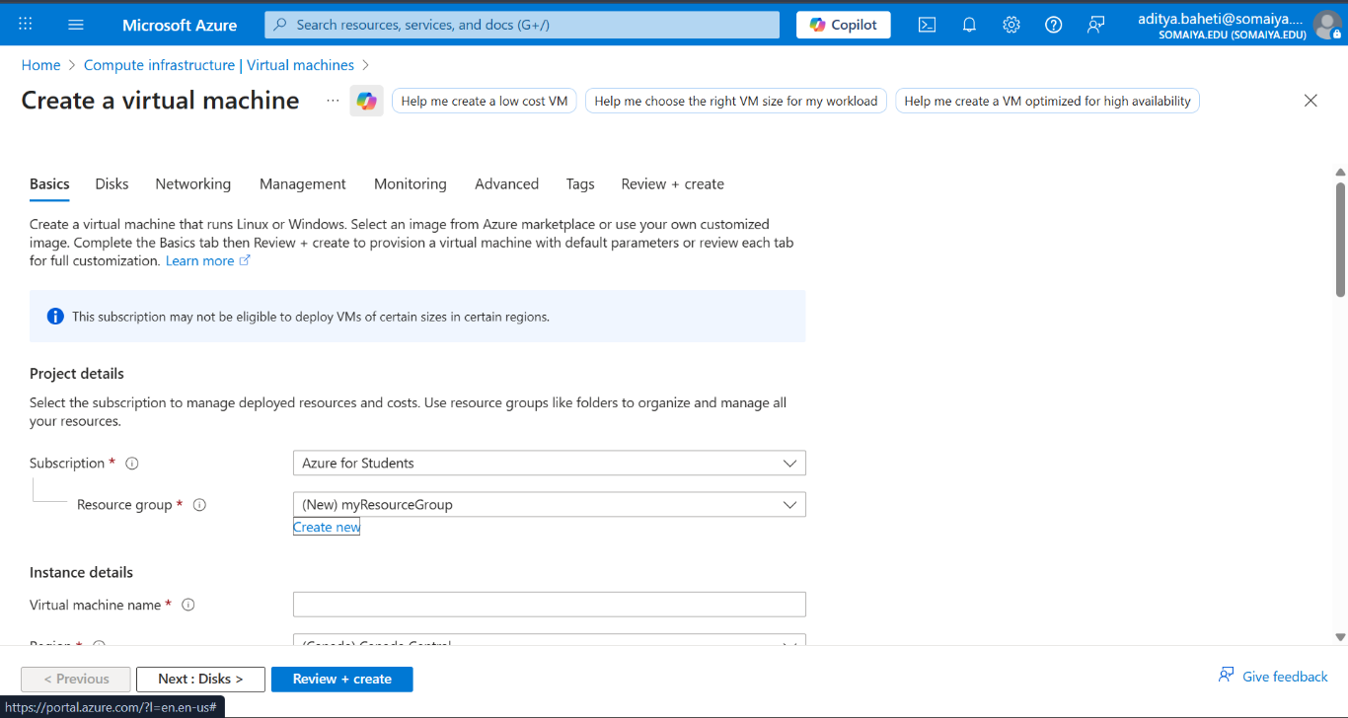
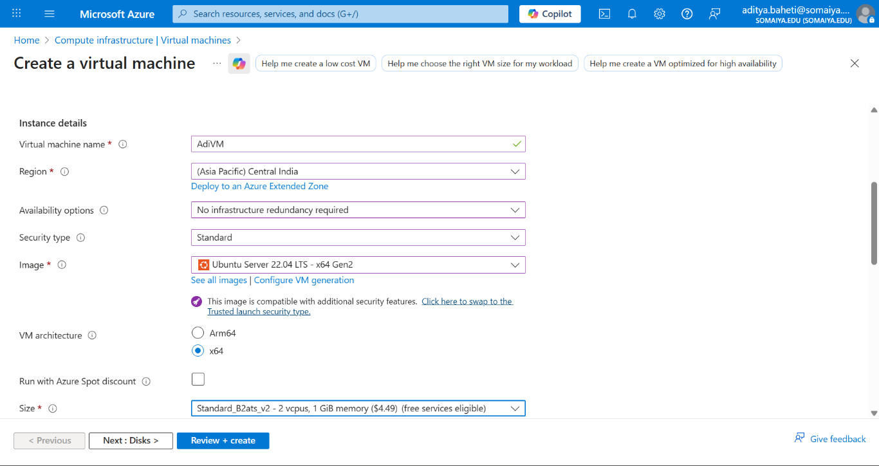
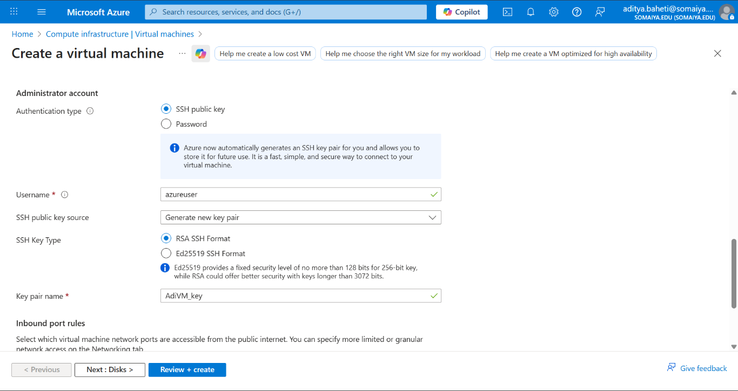
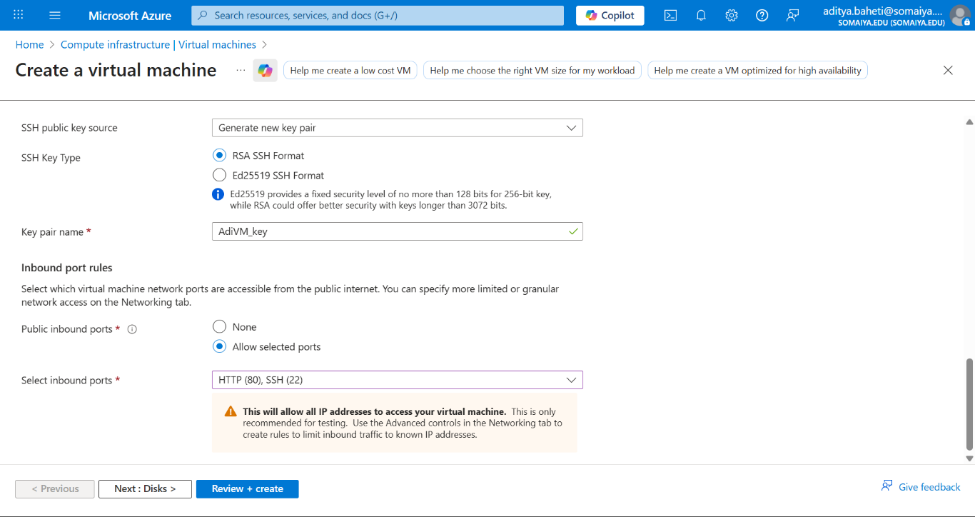
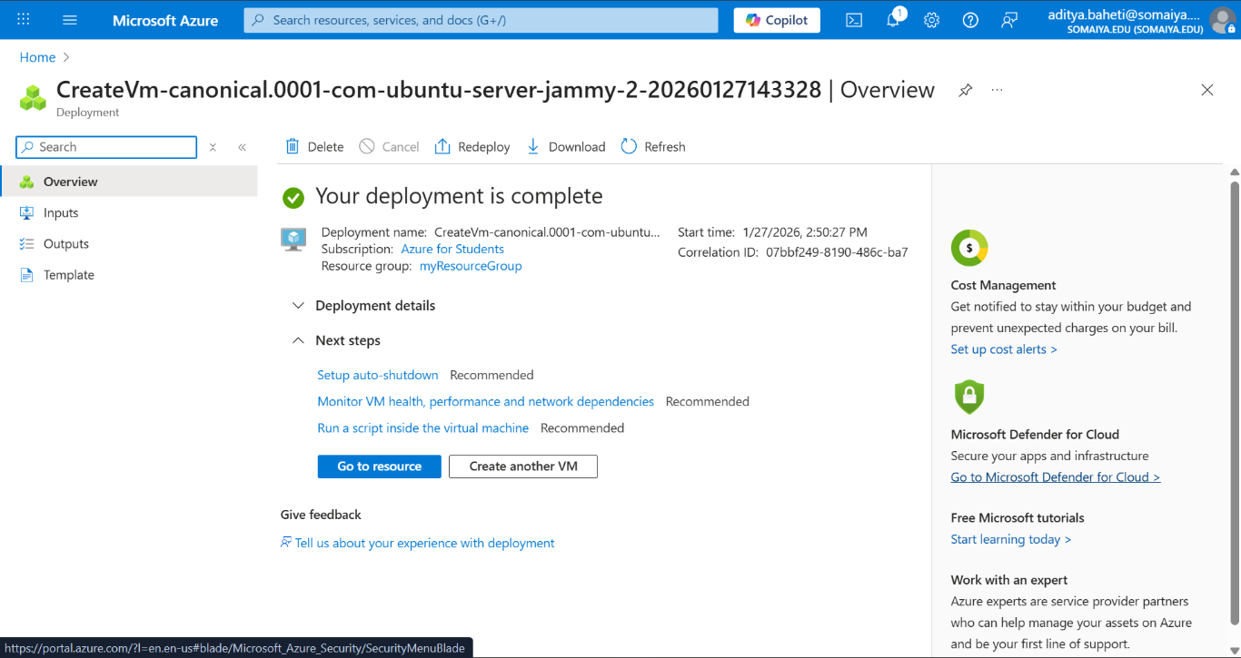
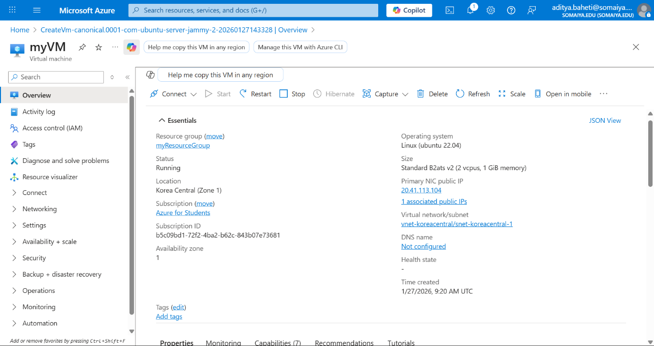

- Accessing VM through local machine and demonstrate linux commands (with Screenshots)
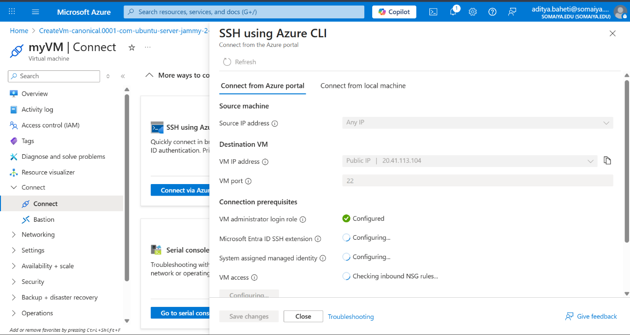
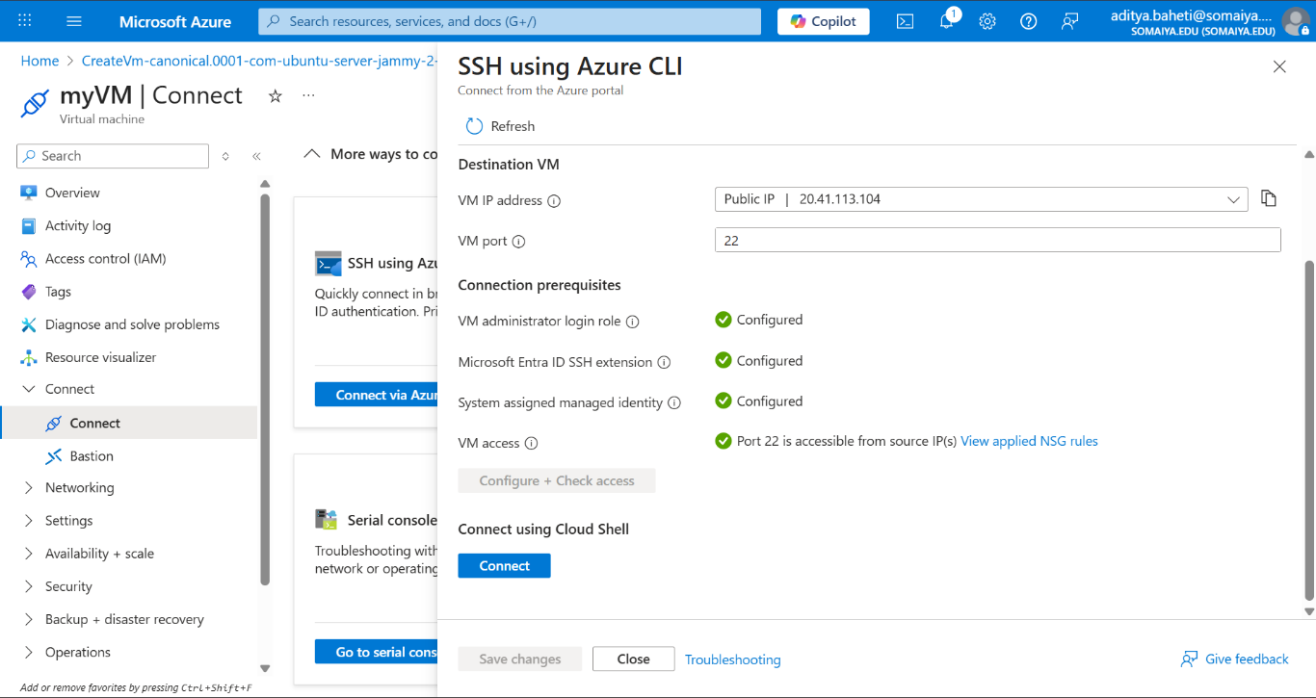
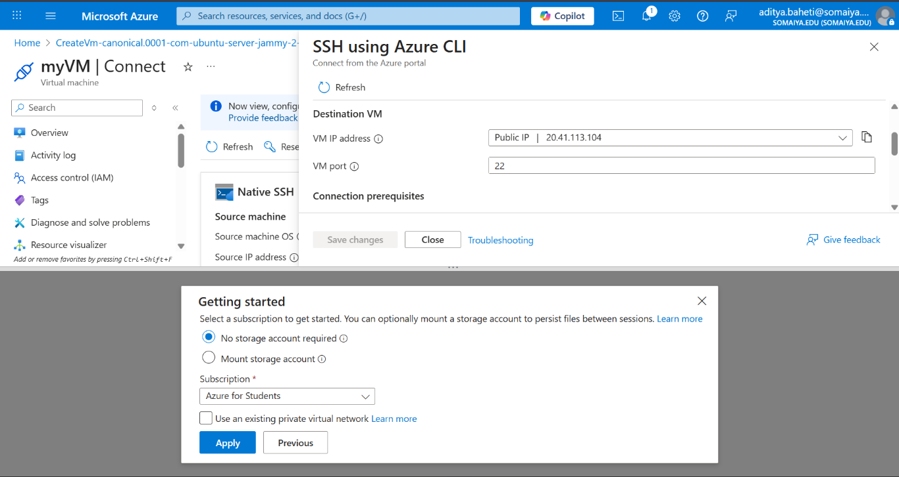
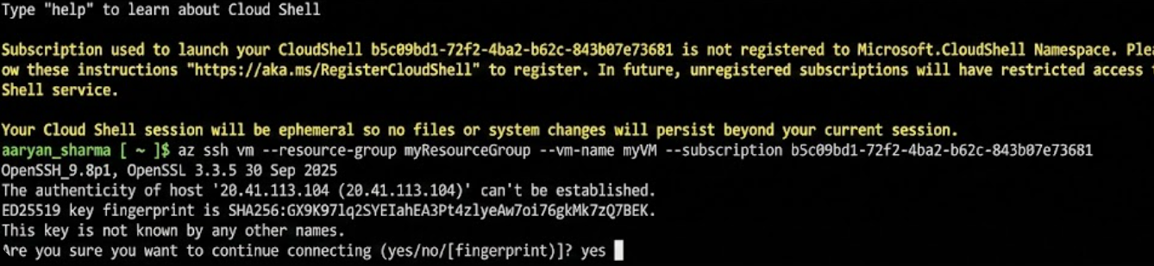
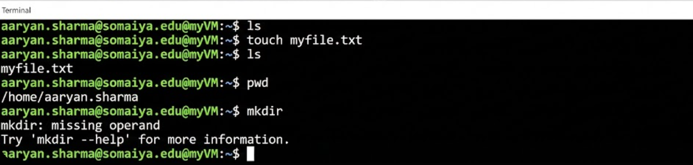

Post Lab Questions:

- Why does deploying a web application using Azure App Service fall under the Platform as a Service (PaaS) model? (Consider OS, runtime, and infrastructure management)
Deploying a web application using Azure App Service falls under the Platform as a Service (PaaS) model because Azure manages the complete platform on which the application runs. In this model, the user does not have to worry about the operating system, runtime environment, or underlying infrastructure. Azure automatically takes care of OS installation, updates, and security patches, and it provides built-in support for common runtimes such as .NET, Java, Python, and Node.js. Additionally, all infrastructure components like servers, storage, networking, load balancing, and scaling are handled by Azure. As a result, developers can deploy their applications directly without managing virtual machines or servers, which is a key characteristic of PaaS.

- What responsibilities are handled by Azure in a PaaS-based web application deployment, and what responsibilities remain with the user?
In a PaaS-based web application deployment, responsibilities are clearly shared between Azure and the user. Azure is responsible for managing the physical data centers, servers, virtualization layer, operating system maintenance, runtime environments, and platform-level security, availability, and scalability. The user, on the other hand, remains responsible for the application layer, which includes writing and maintaining the application code, configuring the application settings, managing application data, and implementing features such as authentication, authorization, and business logic. The user must also ensure secure coding practices and monitor the application’s performance. This separation of responsibilities allows users to focus on application development while Azure ensures that the platform remains stable, secure, and highly available.

Conclusion:
This experiment helped in understanding how to create and use a Linux Virtual Machine on the Microsoft Azure platform. By deploying the VM and accessing it from a local machine, basic Linux commands were successfully performed. The experiment also provided practical insight into cloud computing, especially the PaaS model, where Azure manages the infrastructure and platform while users focus on applications. Overall, it strengthened hands-on knowledge of Azure services and cloud-based application deployment.

